2026 State CDC Pants Pledge

The 2025-2026 Executive Officers would like to promote professional dress slacks at this year’s State CDC. All attendees are encouraged to sign the 2026 Pants Pledge.

Every attendee that turns in a signed Pants Pledge and wears pants the entire conference (excluding the Silent Disco event) will receive the following:

- Pants Pledge Name Badge Ribbon

Pants Pledge Qualifications for Males & Females:
Professional Dress Slacks similar to Dockers and other makers of cotton or synthetic material pants. Inappropriate slacks or pants include jeans, sweatpants, exercise pants, carpenter pants, cargo pants, shorts, bib overalls, leggings, and any spandex or other form-fitting pants.

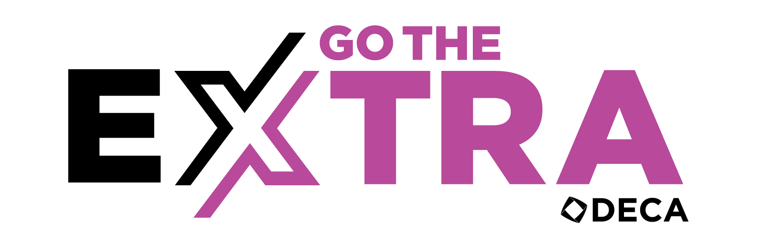

I, ___________________________________ agree to accept the Pants Pledge and wear professional dress slacks throughout the entire State CDC Conference. This includes all times I am outside of my hotel room.

__________________________________________________________________
Attendee Signature

__________________________________________________________________
Attendee School

