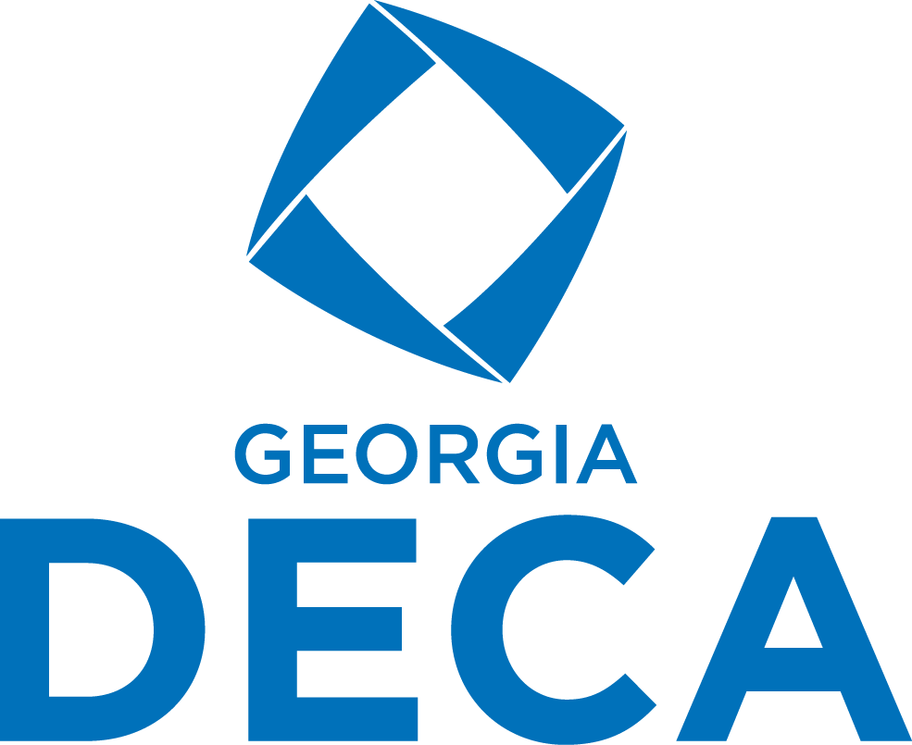

Membership Recruitment Display Competition
Purpose: To showcase innovative and effective strategies used by chapters to recruit new DECA members.
Competition Overview:
Each participating chapter will create a visual display highlighting how they recruit members into their DECA chapter. This is an opportunity to share best practices, inspire others, and celebrate creative recruitment efforts.

Display Details:
- Each chapter will be provided with one standard ½ table to set up their display.
- Displays should clearly communicate the chapter’s recruitment efforts and successes.
- Use visuals, photos, handouts, QR codes, videos (on laptops/tablets), and interactive elements.
- Displays must be set up between 9am-9:45am on September 2nd and remain in place until the closing session.
*Displays should showcase recruitment ideas and content that other chapters could possibly take back and use in their own chapter recruitment.

Awards & Prizes:
- Top 3 Chapters will be announced during the WorkWinWow Closing Session.
- Winners will receive exclusive Georgia DECA Swag Boxes.
- The 1st Place Chapter will also receive 1 free Fall Rally Registration.

Judging Criteria for Voting Chapters:
- Creativity & Visual Appeal
- Clarity of Message
- Effectiveness of Recruitment Strategies
- Engagement and Interactivity

