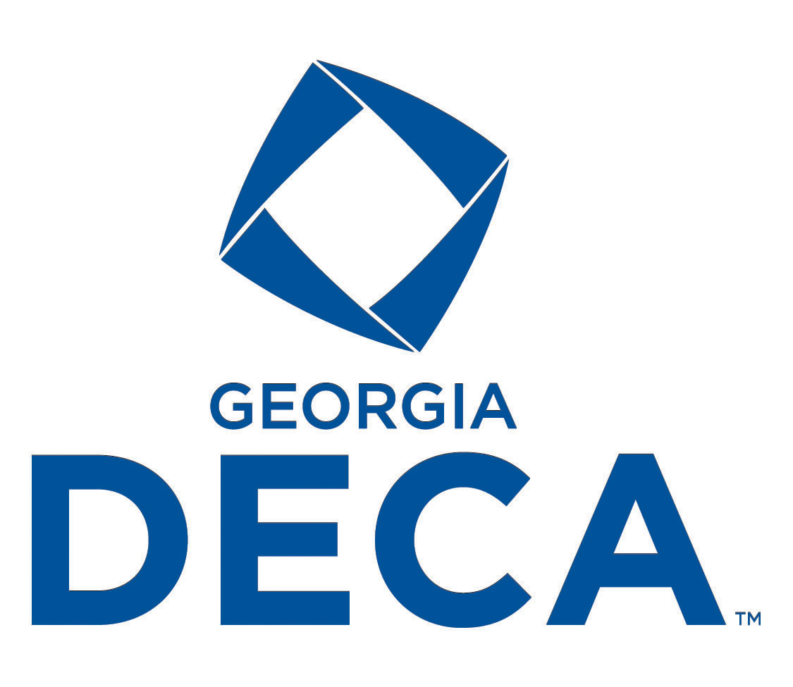**2024 Georgia DECA Fall Rally**

**Wednesday, October 2, 2024**

**Six Flags Over Georgia**

**Join us for the Georgia DECA Fall Rally at Six Flags! You will enjoy a day of networking among other DECA members, a motivational speaker will inspire you to jumpstart your DECA year and we will have several chapter competitions!**

**Agenda:**

9:30am Registration & Check In

10:00am -5:00pm Rides Open

11:00am-1:00pm Competitions-Six Minutes to Sell Six Flags & Be the One Membership Recruitment

11:00am Motivational Rally 1 (Groups Red, Yellow, Blue)

1:00pm Motivational Rally 2 (Groups Green, Orange, Purple)

11:30am-1:30pm Lunch (each group is assigned a time)

3:00pm Awards Session

5:00pm Park/Rides Close

**Registration:**

**Online at** <https://www.decaregistration.com/ga-fallrally/Main.asp>

**August 1-September 6**

**Early Bird Registration** *(submitted by 8/30)* **$70**

**Regular Registration** *(submitted by 9/6)*  **$85**

**Late or Onsite Registration** *(emailed after 9/6)* **$130**

*(chapter will be charged a $25 penalty fee for payment after 9/20)*

**Registration Includes: Six Flags Admission, General Session, and Lunch**

Registration will be open August 1-September 6. Payment must be **in the office** no later than September 20, 2024. Payments not received by September 20th will be charged a $25 penalty fee this includes late and onsite registrations. Credit Card Payments will incur a 5% processing fee.

**No Refunds**

**Remit payment (school check or money order) to:**

**Georgia DECA**

**PO Box 189 Oxford, GA 30054**

**2024 Georgia DECA Fall Rally Competitions**

Georgia DECA will have 5 competitive events at the Fall Rally!

* **Chapter T-shirt Design**
* **Fall Rally Recruitment Flyer**
* **Georgia DECA Button Design**
* **Six Minutes to Sell Six Flags**
* **Be The One Membership Recruitment**

You must register for each competition on the Fall Rally Registration site no later than September 6th

**Competition Recognition for**

**T-shirt, Flyer, & Button Events**

**Top 3 will be recognized in each event**

1st Place- Plaque, 1 State CDC Paid Registration

2nd Place- Plaque

3rd Place- Plaque

**Competition Recognition for**

**Six Minutes & Be the One Event**

All Participants in the Top 2 Teams from each Assigned Group will receive

1 medal for each team member

**Required Forms to Bring with You to Fall Rally:**

* Permission Forms for each chapter attendee (including chaperones and advisors)
* Professional Standards form for each student

**Lunch**

Lunch will be provided for all registered attendees. Lunch will include an All You Can Eat Buffet- Fried Chicken Filet Sandwiches, Beef Hot Dogs, Baked Beans, Potato Chips, Ice Cream Bars. Coca-Cola Products. Please indicate on the registration site if you have any dietary restrictions.

**Fall Rally Attire:**

Appropriate Casual Dress- Longer-length shorts (no short-shorts), neat jeans, polo shirts, sweat shirts, appropriate t-shirt and casual footwear. Chapter T-shirt & Jeans/Shorts are preferred.

**GEORGIA DECA**

**PROFESSIONAL STANDARDS**

For each person attending any Georgia DECA sponsored conference, he/she must read and sign the code of conduct. A copy of the code of conduct must be turned in for each person attending the conference. Deviation from this Code of Conduct will result in the student/school being sent home from the DECA activity.

Georgia DECA wants every person to have an enjoyable experience with every attention paid to safety and comfort. All participants will be expected to conduct themselves in a manner best representing the nation’s greatest student organization.

Note that attendance is not mandatory. By voluntarily participating, you agree to follow the official conference rules and regulations or forfeit your personal rights to participate. We are proud of our students and know that by signing this Code of Conduct, you are simply reaffirming your dedication to be the best possible representative of Georgia DECA. If a student gets in trouble at any DECA Conference/Event they will no longer be able to participate in DECA.

**1. I will, at all times, respect all public and private property, including the hotel/motel in which I am housed.**

**2. I will spend each night in the room of the hotel/motel to which I am assigned.**

**3. I will strictly abide by the curfew established and shall respect the rights of others by being as quiet as possible after curfew.**

**4. I will not visit in the sleeping room of the opposite sex.**

**5. I will not use/possess/or have knowledge of others using/possessing alcoholic beverages or drugs.. I will not use drugs unless I have been ordered to take certain prescription medications by a licensed physician. If I am required to take medication, I will at all times, have the orders of the physician on my person.**

**6. I will not leave the hotel/motel without the express permission of my advisor. Should I receive permission, I will leave a written notice of where I will be. My conduct shall be exemplary at all times.**

**7. I will keep my advisor informed of my whereabouts at all times.**

**8. I will, when required, wear my official identification badge.**

**9. I will not smoke/vape while at any DECA event.**

**10. I will attend & be on time for, all general sessions & activities that I am assigned to and registered for.**

**11. I will adhere to the dress code at all required times.**

**12. I will act respectfully at the dance or I understand that I will be ask to leave.**

**Attending the DECA Dance is a privilege. All attendees must abide by the following guidelines:**

-Sexually explicit dancing is not permitted. Any dance simulating sexual moves is not allowed.

-At the discretion of the DECA advisors, chaperones, or security, a student may be asked to leave the dance for inappropriate dancing or inappropriate behavior.

-School dress codes apply to the DECA dance. Jeans and a DECA t-shirt would be considered appropriate attire. Midriffs, spaghetti straps, muscle shirts, pajamas, and mini skirts ARE NOT considered appropriate. Students in dress code violation will be ask to leave the dance.

**Code of Conduct Agreement**

I agree that if, for any reason, I am in violation of any of the rules of the conference, I may be brought before the appropriate discipline committee for an analysis of the violation. I also agree to accept the penalty imposed on me. I understand that any penalty and reasons for it will be explained to me before it is carried out. I further realize that this conference is designed to be an educational function and all plans are made with that objective. If I am removed from the conference I forfeit the right to participate in any future DECA Event or Conference.

***___________________________________ __________________________________***

***Student Attendee Signature Parent Signature***

***Copies of this form must be kept on hand by the DECA Chapter Advisor during the conference.***

**GEORGIA DECA**

**CONFERENCE ATTENDANCE PERMISSION FORM**

This is to certify that ____________________________________________________________

*(Print Student’s Name)*

has my permission to attend the DECA activity on ___________________________________.

*(Print Date)*

I also do hereby, on behalf of ______________________________________________________

*(Print School Name)*

absolve and release the school officials, the DECA chapter advisors and the assigned state DECA staff from any claims for personal injuries which might be sustained while in route to and from or during the DECA sponsored activity. I understand that during the conference, Georgia DECA will be taking pictures of students and advisors to use in promotional material. It is also my understanding that the mode of transportation will be_______________________________.

*(Print Mode of Transportation)*

**EMERGENCY**

I authorize the advisor to secure the services of a physician or hospital, and to incur the expenses for necessary services in the event of accident or illness, and I will provide for the payment of these costs.

We have read and agree to abide by the DECA Professional Standards. We also agree that the school officials, the DECA chapter advisors and/or the state DECA staff have the right to send the above name student home from the activity, provided that he/she has violated the DECA Professional Standards and/or his/her conduct has become a detriment to the success of the conference. We also understand he/she will not be allowed to attend another GA/National DECA Event.

___________________________________ ____________________________________

Print Name of Student Attending Student Signature

___________________________________ ____________________________________

Insurance Company Name Policy Number

If insurance information is not provided, all signatures below are made in acknowledgement of the fact.

___________________________________ ____________________________________

Parent/Guardian Signature Home Phone Number

___________________________________

Chapter Advisor

___________________________________

School Official Signature

***Please note: Copies of this form must be kept on hand by the DECA Chapter Advisor during the conference.***

**CHAPTER T-SHIRT DESIGN EVENT**

Shannon Aaron- Coordinator

770-630-3967- [georgiadeca@gmail.com](mailto:georgiadeca@gmail.com)

Submit 1 chapter t-shirt design on the Chapter T-shirt Google Form by 5:00pm on September 6, 2024

**Google Form Submission:**

**https://forms.gle/5ahAunUTZaYkebkr6**

**GUIDELINES:**

1. Entries are limited to one entry total per chapter
2. Entries must be the original ideas of the local chapter
3. Entries should contain the t-shirt only, no other printed materials should be submitted
4. DECA logo is optional for the design (refer to the national website for further details on proper logo usage [www.deca.org](http://www.deca.org)) Incorrect usage of the DECA logo will result in disqualification.
5. One t-shirt should **be submitted, as a PDF, on the Google Form**
6. Chapters are strongly encouraged to wear their Chapter T-shirt to Fall Rally
7. T-shirts will be judged and winners will be announced by October 2nd.

**EVALUATION:**

1. Visual Appearance (does it look visually appealing? would students really wear it? is it too busy?) -20 points
2. Creativity (does it have a theme? was thought put into it or was it just put together quickly? was it an original design?) -20 points
3. Use of Graphics (are there too many graphics? not enough? are they placed well? does it make sense? is it relevant to DECA or the theme of the shirt?) -20 points
4. Overall Design (does it stand apart from other chapter shirts? could it be used as a state conference shirt? would any chapter member want to wear it?)- 40 points

**FALL RALLY RECRUITMENT FLYER EVENT**

Shannon Aaron- Coordinator

770-630-3967- [georgiadeca@gmail.com](mailto:georgiadeca@gmail.com)

Submit 1 chapter flyer design on the Google Form by

5:00pm on September 6, 2024.

**Google Form: https://forms.gle/5ahAunUTZaYkebkr6**

**GUIDELINES:**

1. Entries are limited to one entry total per chapter
2. Flyer should detail information about recruiting local members to attend the Georgia DECA Fall Rally.
3. Entries must be the original work of the local chapter. Copy ready flyers provided by the state or national offices are not acceptable. Official logos may be used, however
4. Entries must be saved as a PDF and limited to 1 page maximum. They may be portrait or landscape.
5. Flyer may be color or black and white.
6. One flyer should be uploaded to the Google Form
7. Flyers will be judged and Winners will be announced by October 2nd.

**EVALUATION:**

1. Effectiveness of the Message (what is Fall Rally, how to attend, what do you get out of it) (20 points)
2. Page layout, principles used in design, clip art selection & placement, font selection & usage (did it flow well and was it easy to read as a flyer) (20 points)
3. Creativity (this is what sets some apart, color usage, theme??) (20 points)
4. General Appearance (neatness, legibility, balance, was it easy to read? did it have too many words? too many pictures?) (20 points)
5. Accuracy and Appeal of Information provided (was it easy for a high school student to know about Fall Rally if that was the first they heard of it) (20 points)

**GEORGIA DECA BUTTON DESIGN EVENT**

Shannon Aaron-Coordinator

770-630-3967-georgiadeca@gmail.com

Submit 1 Button design on the Google Form by 5:00pm on September 6, 2024.

**Google Form: https://forms.gle/5ahAunUTZaYkebkr6**

**Purpose:**

To allow Georgia DECA members to develop an authentic Georgia DECA button that can be worn to local, regional, state, and national meetings that will identify Georgia DECA members. The winning design will be chosen for its ability to catch the consumer’s eye and depict Georgia DECA pride. First, Second, and Third Place will be awarded.

**GUIDELINES:**

1. Entries are limited to one individual student per chapter
2. Chapters will design a DECA button that can be worn on blazers, jackets, shirts, sweaters, or blouses.
3. Button Design should reflect Georgia DECA- could include elements related to cities, conferences, events, leadership, etc.
4. One Button Design should be submitted as a PDF in the Google Form.
5. Button Designs will be judged and Winners will be announced by October 2nd.

**GENERAL INFORMATION**

* Georgia DECA reserves the right to make any changes to the design which may conflict with its production
* All button designs become the property of Georgia DECA. When a contestant enters a design, he or she relinquishes all rights for the sale and use of the design to Georgia DECA.

**EVALUATION:**

1. Layout and Design (25 points)
2. Creativity and Originality (25 points)
3. Workmanship (25 points)
4. Suitability (15 points)
5. Overall Impression (10 points)

**Six Minutes to Sell Six Flags Event**

Shannon Aaron-Coordinator

770-630-3967-georgiadeca@gmail.com

Register on the Fall Rally Registration Site. Only registered chapters can participate.

Competition will take place at Six Flags

**GUIDELINES:**

1. Entries are limited to one **Team of 2 or 3** per chapter.

2. Students must present an exciting and innovating “Event Night” for Six Flags. The Event Night must appeal to the Generations: Boomers-Elderly (60+)It is purely a "pitch" with nothing but the value of the idea and the presentation skills to support it.

3. Order of competition will be pre-assigned on a random selection basis. Competitors will present within different groups. The top 2 teams from each group will be recognized.

4. Competitors may use 3x5 index cards only for brief outline/key idea. No props. Handouts are allowed but not required. No items of monetary value or food are allowed.

5. The presentation shall be a maximum of six (6) minutes in length. The timekeeper shall give a 1 minute warning. The competitor will be stopped when the six minutes are up.

7. Fall Rally attire will be appropriate for this event.

**EVALUATION:**

Creativity (25 points)

Quality of Content (25 points)

Organization of Information (25 points)

Delivery (25 points)

**AWARDS:**

The top 2 teams from each judge will be awarded a medallion for each team member.

**Be The One Membership Campaign**

Shannon Aaron-Coordinator

770-630-3967-georgiadeca@gmail.com

Register on the Fall Rally Registration Site. Only registered chapters can participate.

Competition will take place at Six Flags

**GUIDELINES:**

1. Entries are limited to one **Team of up to 3** per chapter (entries can have 1, 2, or 3 team members but no more than 3).

2. Students must present ideas on how their chapter plans to Be the One this year in regards to Membership, Participation, Community Service, Promotion, Recognition and Competition.

3. Order of competition will be pre-assigned on a random selection basis. Competitors will present within different groups. The top 2 teams from each group will be recognized.

4. Competitors may use 3x5 index cards only for brief outline/key idea. No props. Handouts are allowed but not required. No items of monetary value or food are allowed.

5. The presentation shall be a maximum of five (5) minutes in length.

7. Fall Rally attire will be appropriate for this event.

**EVALUATION:**

Creativity (25 points)

Quality of Content (25 points)

Organization of Information (25 points)

Delivery (25 points)

**AWARDS:**

Top 2 Teams from each judge will receive a medallion for each team member