2025 Georgia DECA Fall Rally Competitions

Georgia DECA will have 5 competitive events at the Fall Rally!

- Chapter T-shirt Design
- Georgia DECA Button Design
- Georgia DECA Statesman Exam
- Six Minutes to Sell Six Flags
- Go the Extra Theme Speech Competition

You must register for each competition on the Fall Rally Registration site no later than September 5th

Competition Recognition for
T-shirt & Button Events
Top 3 will be recognized in each event

1st Place- Plaque, 1 State CDC Paid Registration
2nd Place- Plaque
3rd Place- Plaque

Competition Recognition for
Six Minutes & Go the Extra Theme Speech Event

All Participants in the Top 2 Teams from each Assigned Group will receive
1 medal for each team member

Competition Recognition for
Statesman Exam

All students who score a 90% or higher on the Statesman Exam will receive a Statesman Pin and Certificate
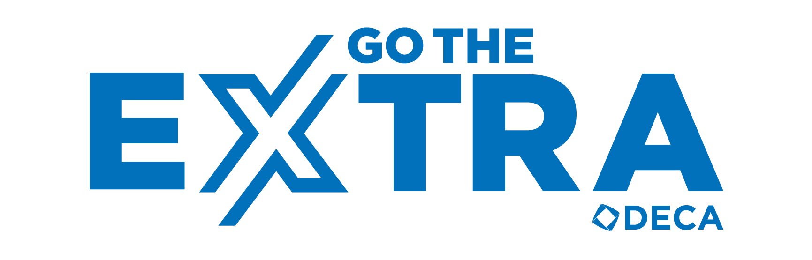

All winners will be announced at the 3pm Awards Session at Fall Rally. In addition to the awards above, 5 chapters will be randomly drawn during the Awards Session to receive a free DECA Blazer.
Must be present to win the blazer.

